Chapter 2 - Definitions

Four pillars

2.1 - Introduction
On more than one occasion, people working with machine learning engineers and data scientists expressed that they were unsure what the difference is between data science, machine learning, and artificial intelligence. So, it is worth spending some time delineating these concepts. In this first module, we will spend some time defining the various terms and discussing where they overlap and where they do not.

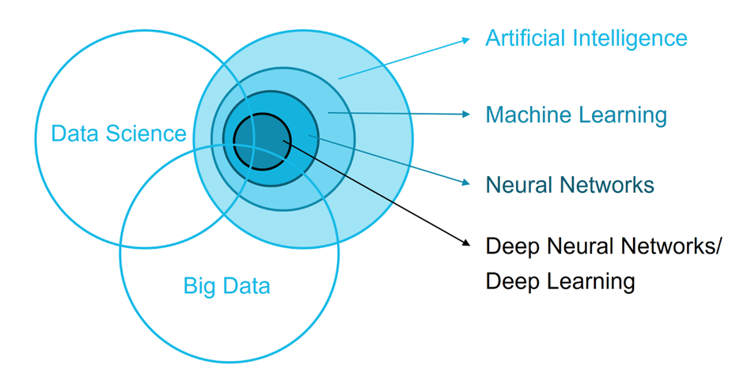
Figure 2-1 - One interpretation of the intersection of data science, artificial intelligence, and machine learning. What about your Venn diagram?

2.2 - Data Science
Data science aims to derive insights, structure, correlations, and causal inferences from data. It seeks to predict previously unobserved outcomes from new inputs. It uses a combination of statistical models, mathematics, and computer algorithms to derive these insights and predictions. These algorithms are used to prove or disprove hypotheses. An algorithm designed and tested to perform as expected can be moved into production. One will typically see data scientists joining forces with engineers (specifically machine learning engineers) to ensure the algorithm is correctly placed in the company's technology ecosystem and infrastructure.

2.3 - Artificial Intelligence
In contrast, Artificial Intelligence (AI) refers to the endeavor to endow non-biological systems with human or animal-like intelligence. These systems adapt and learn from interaction with their environment. Some are designed to interact with humans, like the Sony AIBO in Fig. 2.2, intended to be an AI pet. Others are operating autonomously, requiring no human interaction or guidance. In general, the term 'artificial intelligence' is mainly meant to be conceptual, acknowledging that there is something like intelligence. In some way, we can create that artificially in a machine, robot, an internet of things (IoT) device, or computer. The current consensus is to achieve that intelligence through machine learning.

2.4 – Machine Learning
Machine learning is the toolkit of both data science and artificial intelligence. It tests specific data science hypotheses and implements AI by creating algorithms that can transform a set of input data into desirable outcomes and predictions.
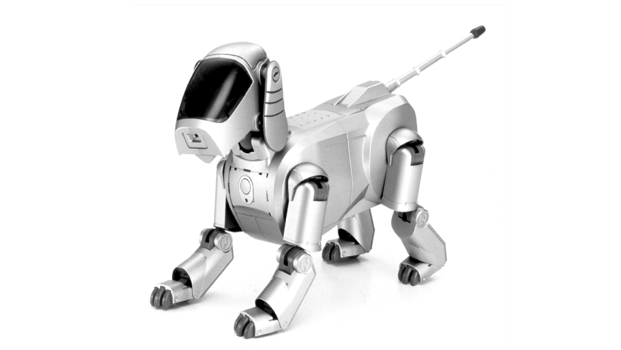
Figure 2.2 - The Sony Aibo robot dog. An expensive toy, but to many people, the first introduction to artificial intelligence and robotics combined.

Machine learning aims for algorithms to find their solutions to a given problem: by learning and adapting to data not seen by the algorithm. Machine learning algorithms allow data scientists to build algorithms whose output can drive genuine business decisions. Machine learning algorithms will enable us to create AI solutions to have them interact with the environment in a meaningful way, like machine vision, natural language processing, speech recognition, navigation, knowledge extraction, etc.

2.5 – User experience and design
As our AI becomes more embedded, ambient, and human-like (although this is not necessary), designing the interface between the user and technology will require a different approach. In most cases, our machine learning and AI solutions will not live in a vacuum but will be embedded into a tangible product. This embedding requires thought on how to design an optimal interface and experience. User experience is the human-first way of designing solutions regardless of the medium. On the other hand, user interface design focuses on the actual touch points of interaction between the user and technology. The goal moving forward is to remove this differentiation between these two design approaches altogether.

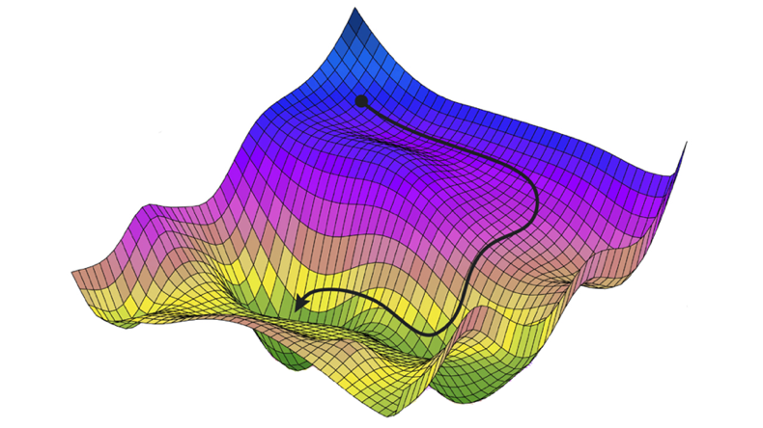
Figure 2-3 - A visual representation of gradient descent, one of the critical ingredients of getting algorithms to learn.

Currently, we design the interface between humans and technology through skeuomorphism - making the various elements of the interface resemble or mimic real-world counterparts. For example, the graphical representation of an email still used by most software is the little envelope. And the icon for saving a file still resembles a floppy disc, even though most users today will never have used an actual floppy disc to store their files. And finally, our trusty computer desktop, one of the fundamental design advances that led to the massive adoption of personal computers in everyone's daily. With AI, however, we might not need this skeuomorphism anymore. We can communicate with, query, and instruct our computers in the same way we would communicate with other humans. We can replace the keyboard with voice recognition, the mouse with hand gestures, and our desktop monitors with projections, holograms, etc. So, it will shift our focus from how humans interact best with computers to how humans best interact with other humans.

2.6 – Putting them together
How do these four pillars (artificial intelligence, machine learning, data science, and UX/UI) fit together? We are trying to build and test models between observables (data) and outputs (actions, insights). Modeling is the primary focus of data science. In contrast, machine learning focuses on how to implement these models as algorithms quantifying the input-output relationships. What are the best algorithms giving us the best performance, and how are these algorithms efficiently implemented on different tech architectures and infrastructures? Together, they supply the backbone of AI. But it does not address how to embed the models and algorithms into solutions that sense, actuate, and interact with human beings optimally. This embedding is also why design is an essential part of AI. Embedding an AI solution into a human-centered environment requires understanding human cognition, behavior, and communication and how to use it to design solutions that optimize the user experience and utility of the solution.

2.7 - Alternative definitions
The definitions above are by the authors. Many people have defined the above concepts with varying degrees of overlap. And many people will continue to define them (slightly differently). It is a relatively new field of science and engineering and a rapidly developing one to boot. No doubt, some of the key concepts we consider vital to the definition today might become obsolete or redundant, or even incorrect as we shift paradigms moving forward. We've included some references to definitions by other authors. Perhaps you agree more with these or feel that a more precise definition can be synthesized from the definitions already put forward.

 | Artificial Intelligence | Machine Learning | Data Science
 | A non-human program or model that can solve sophisticated tasks. For example, a program or model that translates text or a program or model that identifies diseases from radiologic images both exhibit artificial intelligence. | A program or system that builds (trains) a predictive model from input data. The system uses the learned model to make useful predictions from new (never-before-seen) data drawn from the same distribution as the one used to train the model. | The ability to extract knowledge and insights from large and complex data sets. Data science work often requires knowledge of both statistics and software engineering.
 | A branch of computer science dealing with the simulation of intelligent behavior in computers or the capability of a machine to imitate intelligent human behavior | The process by which a computer can improve its own performance (as in analyzing image files) by continuously incorporating new data into an existing statistical model | No Definition
 | Intelligence demonstrated by machines, as opposed to natural intelligence displayed by animals, including humans. Leading AI textbooks define the field as the study of "intelligent agents": any system that perceives its environment and takes actions that maximize its chance of achieving its goals. | The study of computer algorithms that can improve automatically through experience and using data. Machine learning algorithms build a model based on sample data, known as training data, to make predictions or decisions without being programmed to do so. It is seen as a part of artificial intelligence. | The interdisciplinary field uses scientific methods, processes, algorithms, and systems to extract knowledge and insights from noisy, structured, and unstructured data and apply knowledge and actionable insights from data across a broad range of application domains.
 | Artificial intelligence systems are used to perform complex tasks in a way that is like how humans solve problems. AI aims to create computer models that exhibit "intelligent behaviors" like humans. | The subfield of artificial intelligence gives computers the ability to learn without explicitly being programmed. | Data science encompasses a set of principles, problem definitions, algorithms, and processes for extracting non-obvious and useful patterns from large datasets. It is closely related to data mining and machine learning but broader in scope.
 | The study and development of computer systems that can copy intelligent human behavior | A type of artificial intelligence in which computers use vast amounts of data to learn how to do tasks rather than being programmed to do them | No Definition

2.8 - References
Wikipedia – DS - https://en.wikipedia.org/wiki/Data_science
Wikipedia – ML - https://en.wikipedia.org/wiki/Machine_learning
Wikipedia – AI - https://en.wikipedia.org/wiki/Artificial_intelligence
Webster – ML - https://www.merriam-webster.com/dictionary/machine%20learning
Webster – AI - https://www.merriam-webster.com/dictionary/artificial%20intelligence
Oxford - https://www.oed.com/
Google – ML - https://developers.google.com/machine-learning/glossary
OpenAI – AI - https://openai.com/charter/
IBM – AI - https://www.ibm.com/design/ai/basics/ai/
IBM – ML - https://www.ibm.com/design/ai/basics/ml
Microsoft – ML - https://azure.microsoft.com/en-us/resources/cloud-computing-dictionary/what-is-machine-learning-platform/
Microsoft – AI - https://azure.microsoft.com/en-us/blog/what-is-artificial-intelligence/
Microsoft – DS - https://learn.microsoft.com/en-us/shows/dev-intro-to-data-science/
Nvidia – AI - https://www.nvidia.com/en-us/glossary/data-science/artificial-intelligence/
Nvidia – ML - https://www.nvidia.com/en-us/glossary/data-science/machine-learning/
Facebook – AI - https://tech.fb.com/artificial-intelligence/
Facebook – DS - https://research.facebook.com/research-areas/data-science/

